1. 
2. 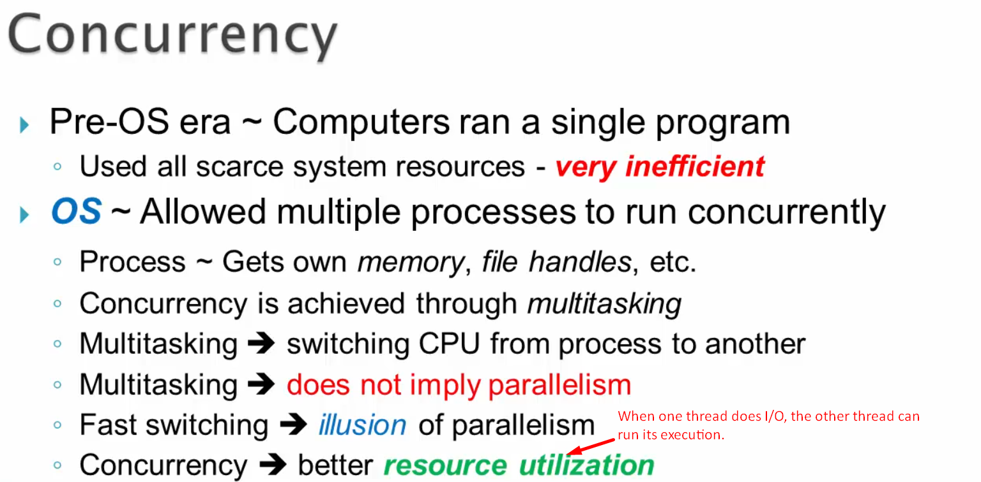
3. **Why Concurrency**?
   1. Users don’t need to wait as each user’s task is being executed by switching the CPU among the threads.
   2. Resource Utilization.
4. 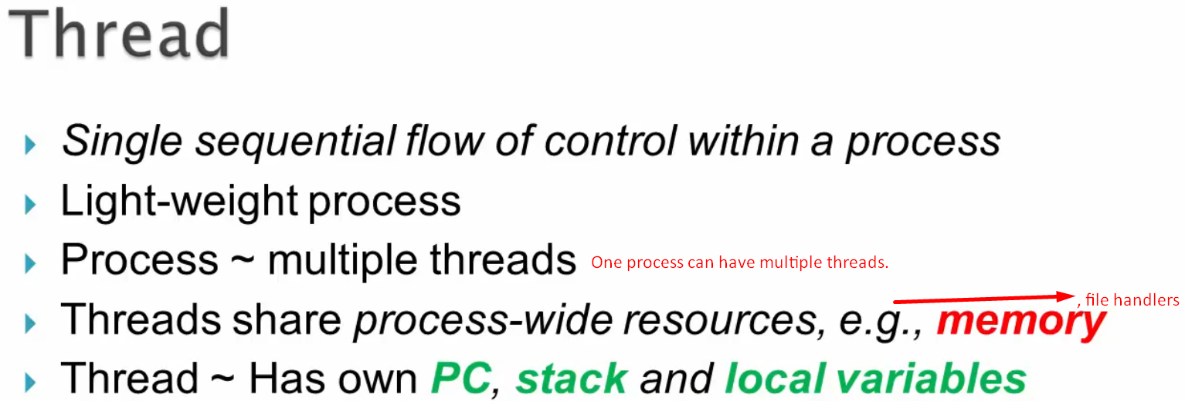
5. 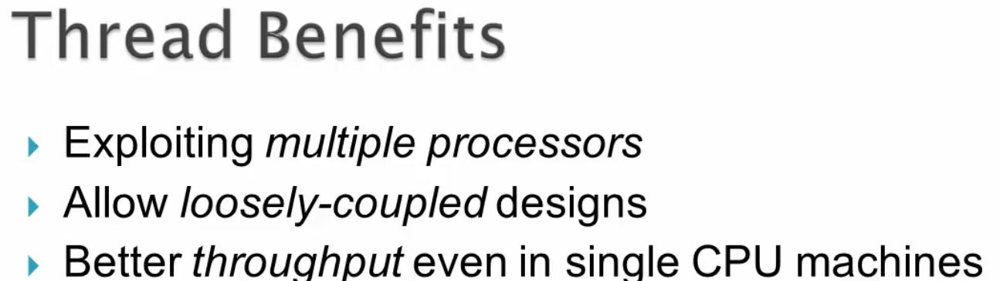
6. 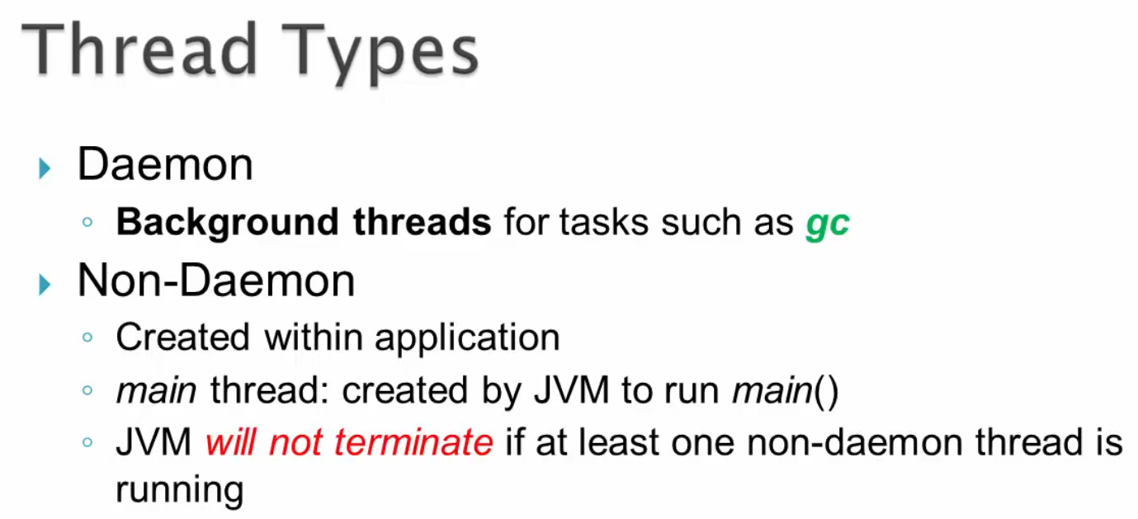
7. 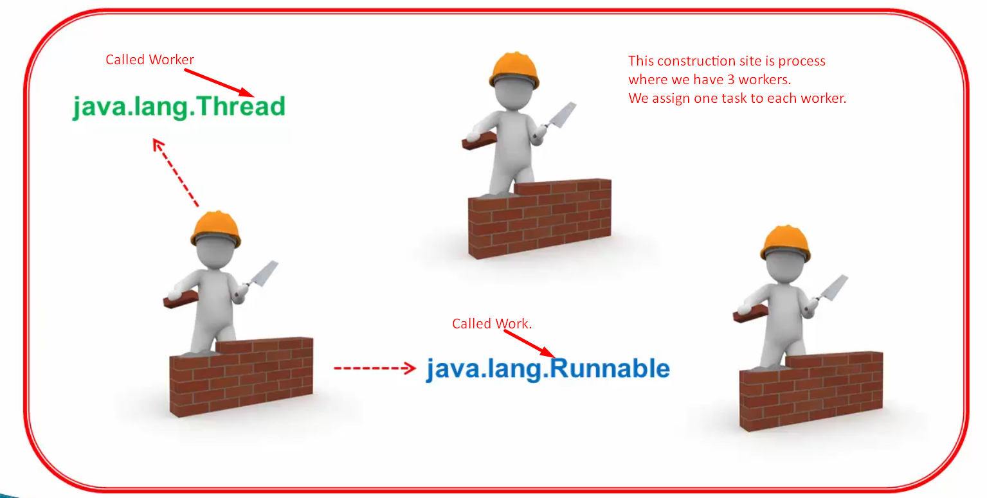
8. 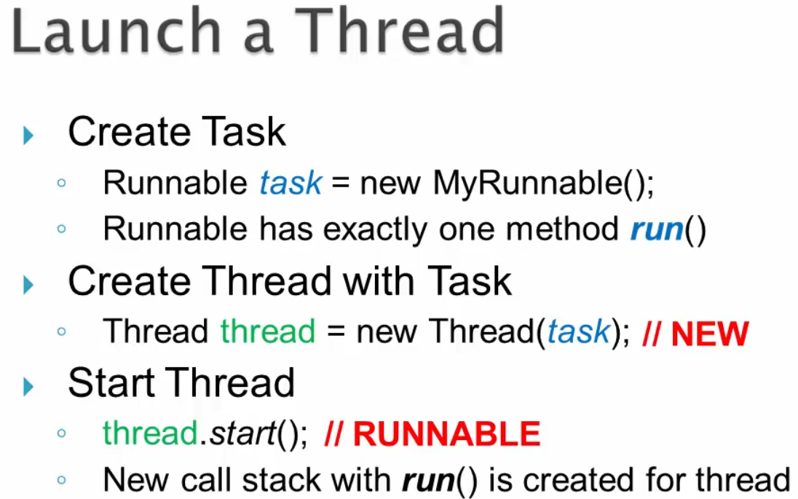
9. 